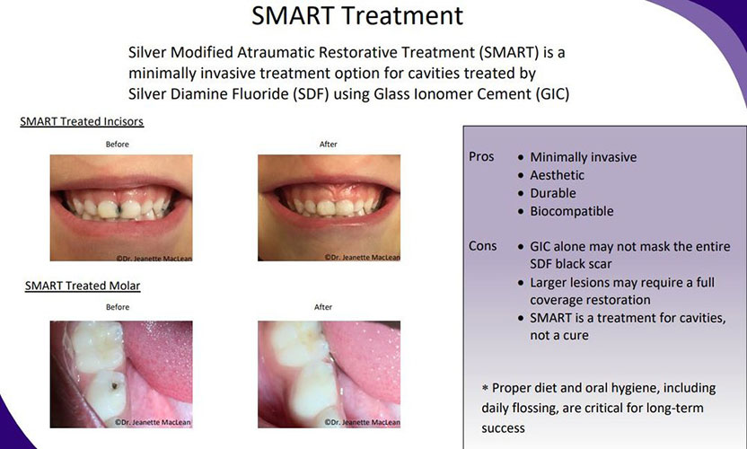https://images.app.goo.gl/bV6np9yE4YR1eX998